**1. Hello World**

* **✅ Room Name and Link:** Hello World -<https://tryhackme.com/room/helloworld>
* **🎯 Learning Objective:** To introduce users to the foundational concepts of TryHackMe, including basic navigation, task interaction, and an initial understanding of the platform's purpose in cybersecurity education.
* **🛠 Key Tools/Commands Used:** Web Browser (Google Chrome, Firefox, etc.), TryHackMe Dashboard, Basic web interaction.
* **🧠 Concepts Learned:**
  + **Platform Introduction:** Understanding TryHackMe as an interactive learning platform for cybersecurity.
  + **Room Structure:** Familiarizing with the layout of a TryHackMe room, including task descriptions and answer submission fields.
  + **Basic Interaction:** Learning how to read and interpret task instructions and input correct answers.
  + **Cybersecurity Relevance:** Gaining a rudimentary understanding of how the platform relates to practical cybersecurity skills.
* **🔍 Walkthrough / How You Solved It:**
  + Created a TryHackMe account and logged in using the provided credentials.
  + Navigated to the "Hello World" room via the provided link.
  + Read the introductory message and proceeded to the first task.
  + Followed the instructions to answer the simple questions, which were designed to test basic platform navigation.
  + Submitted the answers and observed the feedback provided by the platform.
  + Continued through the remaining tasks, ensuring each was completed correctly.
  + Marked the room as complete upon finishing all tasks.
* **💡 Reflections or Notes:** The "Hello World" room effectively serves as a gentle introduction to TryHackMe. Its simplicity allows new users to quickly grasp the basic mechanics of the platform, making it an excellent starting point for those new to cybersecurity.
* 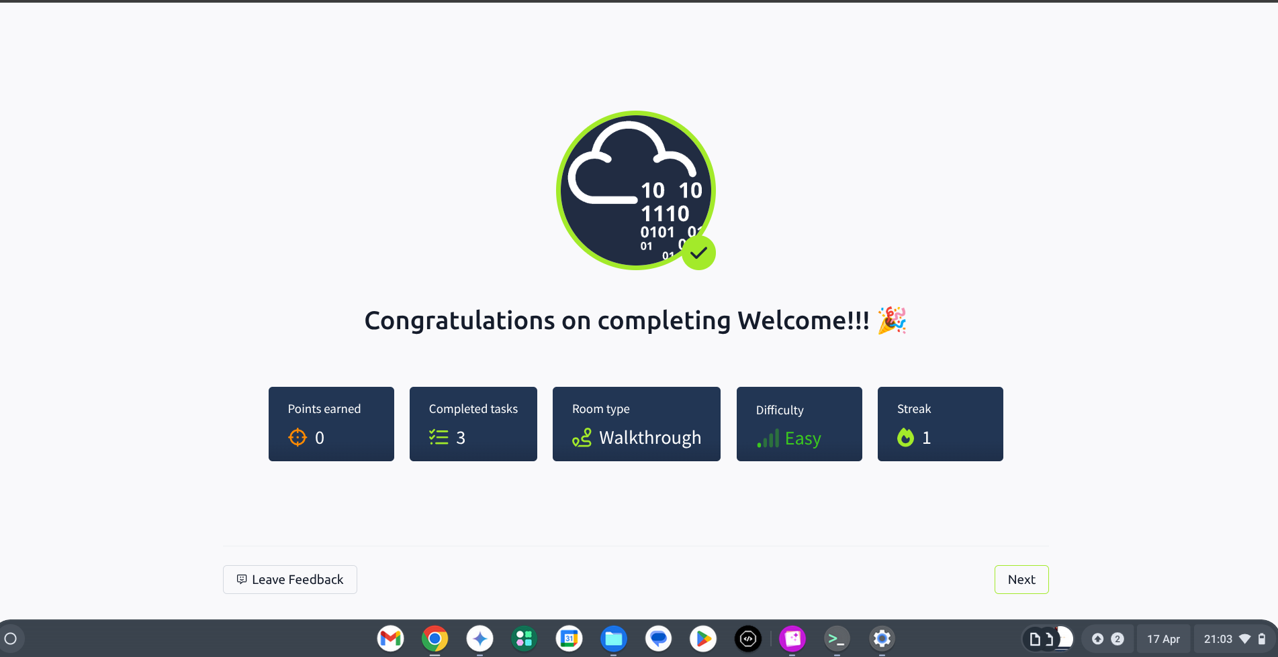

**2. How to Use TryHackMe**

* **✅ Room Name and Link:** How to Use TryHackMe -<https://tryhackme.com/room/howtouse>
* **🎯 Learning Objective:** To provide a comprehensive overview of TryHackMe's core features, including deploying virtual machines, utilizing the AttackBox, and understanding the structure of interactive labs.
* **🛠 Key Tools/Commands Used:** TryHackMe Dashboard, Virtual Machines (VMs), TryHackMe AttackBox, Web based terminal usage.
* **🧠 Concepts Learned:**
  + **Virtual Machine (VM) Deployment:** Learning how to deploy and manage VMs within the TryHackMe environment.
  + **AttackBox Utilization:** Understanding the purpose and functionality of the AttackBox, a pre-configured VM for hacking tasks.
  + **Room Layout and Navigation:** Familiarizing with the various components of a TryHackMe room, such as task lists, question submission fields, and hints.
  + **VPN Fundamentals:** Understanding the basic function of a VPN in securing connections to TryHackMe's network.
* **🔍 Walkthrough / How You Solved It:**
  + Navigated to the "How to Use TryHackMe" room.
  + Followed the instructions to deploy a virtual machine.
  + Opened the AttackBox and explored its interface.
  + Used the AttackBox to interact with the deployed VM and complete the tasks.
  + Explored the room's features, such as the task list, question submission, and hints.
  + Submitted the correct answers and marked the tasks as complete.
* **💡 Reflections or Notes:** This room provides a valuable hands-on introduction to the essential tools and techniques used throughout TryHackMe. It effectively prepares users for more complex challenges by familiarizing them with the platform's core functionalities.
* 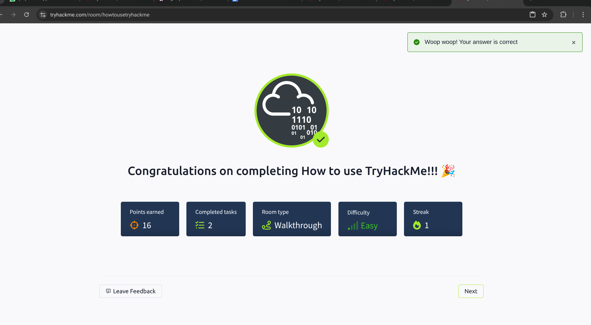

**3. Getting Started**

* **✅ Room Name and Link:** Getting Started -<https://tryhackme.com/room/gettingstarted>
* **🎯 Learning Objective:** To guide users through the process of setting up their environment for practical cybersecurity exercises on TryHackMe, including VPN configuration and VM deployment.
* **🛠 Key Tools/Commands Used:** TryHackMe Dashboard, Virtual Machines (VMs), OpenVPN, Linux commands.
* **🧠 Concepts Learned:**
  + **VPN Configuration:** Understanding the importance of VPNs for secure connections and learning how to set up an OpenVPN connection for TryHackMe.
  + **Virtual Machine Interaction:** Gaining experience in deploying and interacting with VMs for hacking challenges.
  + **TryHackMe Learning Paths:** Understanding the structure and benefits of TryHackMe's learning paths for structured cybersecurity education.
  + **Basic Networking Concepts:** Introduction to IP addresses, network interfaces, and basic network communication.
* **🔍 Walkthrough / How You Solved It:**
  + Navigated to the "Getting Started" room.
  + Followed the instructions to configure an OpenVPN connection using the provided configuration files.
  + Deployed a virtual machine and used the AttackBox to interact with it.
  + Explored the TryHackMe learning paths and identified relevant modules for further study.
  + Answered the questions and completed the tasks within the room.
* **💡 Reflections or Notes:** This room serves as a crucial step in preparing users for practical cybersecurity exercises on TryHackMe. It emphasizes the importance of a secure environment and structured learning paths.
* 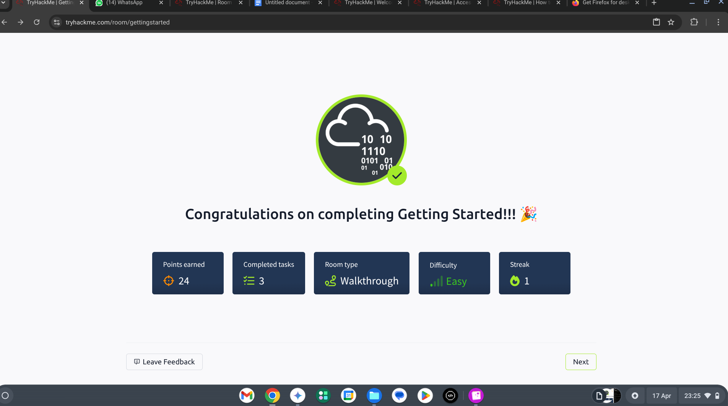

**4. Welcome**

* **✅ Room Name and Link:** Welcome -<https://tryhackme.com/room/welcome>
* **🎯 Learning Objective:** To provide an overview of TryHackMe's mission, goals, and community, and to inspire users to pursue cybersecurity education.
* **🛠 Key Tools/Commands Used:** Web Browser, TryHackMe Dashboard (community features).
* **🧠 Concepts Learned:**
  + **TryHackMe Community:** Understanding the importance of community support and collaboration in cybersecurity learning.
  + **Learning Resources:** Recognizing the diverse range of learning resources available on TryHackMe, including rooms, paths, and challenges.
  + **Cybersecurity Career Paths:** Gaining a general understanding of the various career paths available in cybersecurity.
* **🔍 Walkthrough / How You Solved It:**
  + Navigated to the "Welcome" room.
  + Read the introductory message and explored the community features.
  + Reviewed the available learning resources and career paths.
  + Answered the questions based on the information provided in the room.
* **💡 Reflections or Notes:** This room serves as a motivational introduction to the TryHackMe platform and the field of cybersecurity. It highlights the importance of community and continuous learning.
* 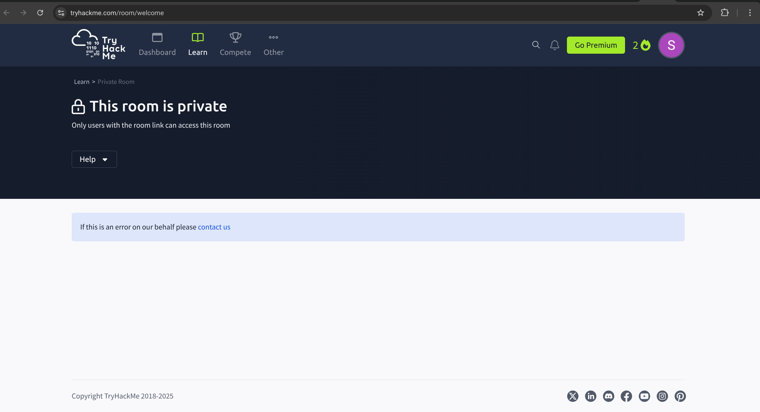

**5. TryHackMe Tutorial**

* **✅ Room Name and Link:** TryHackMe Tutorial -<https://tryhackme.com/room/tutorial>
* **🎯 Learning Objective:** To reinforce the skills learned in previous introductory rooms and to provide a more in-depth tutorial on TryHackMe's interactive features.
* **🛠 Key Tools/Commands Used:** TryHackMe Interface, Task Completion Interface, Interactive Elements (hints, deployable machines, attack boxes).
* **🧠 Concepts Learned:**
  + **Advanced Task Interaction:** Learning how to utilize hints and explanations to solve complex tasks.
  + **Virtual Machine Manipulation:** Gaining proficiency in deploying and interacting with virtual machines for practical challenges.
  + **Efficient Navigation:** Developing strategies for navigating through rooms and learning paths effectively.
* **🔍 Walkthrough / How You Solved It:**
  + Navigated to the "TryHackMe Tutorial" room.
  + Followed the instructions to complete the tasks, utilizing hints when necessary.
  + Deployed and manipulated virtual machines to solve practical challenges.
  + Submitted the correct answers and marked the tasks as complete.
* **💡 Reflections or Notes:** This room builds upon the foundational skills learned in previous rooms and prepares users for more advanced cybersecurity topics.
* 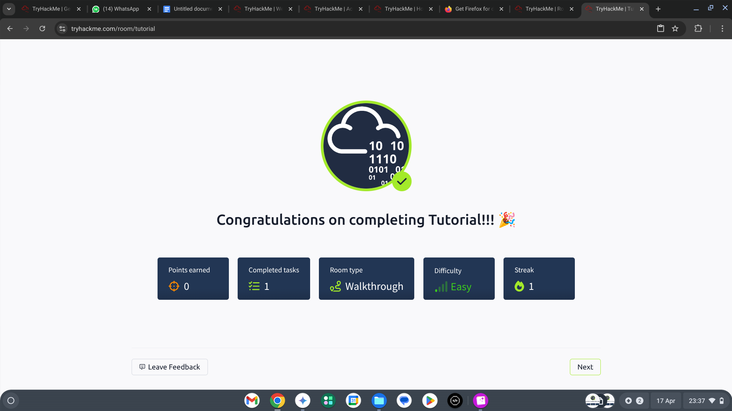

**6. OpenVPN Configuration**

* **✅ Room Name and Link:** OpenVPN -<https://tryhackme.com/room/openvpn>
* **🎯 Learning Objective:** To provide a practical guide to setting up and configuring an OpenVPN connection for secure access to TryHackMe's network.
* **🛠 Key Tools/Commands Used:** OpenVPN Client, Terminal/Command Line (for executing OpenVPN commands), ifconfig or ip addr (for network interface verification).
* **🧠 Concepts Learned:**
  + **VPN Fundamentals:** Understanding the purpose of VPNs in cybersecurity and their role in secure communication.
  + **OpenVPN Installation and Configuration:** Learning how to install the OpenVPN client and configure it using .ovpn files.
  + **Network Interface Verification:** Using command-line tools to verify the VPN connection and network interface.
  + **Troubleshooting Network Connections:** Learning how to diagnose and resolve common VPN connection issues.
* **🔍 Walkthrough / How You Solved It:**
  + Navigated to the "OpenVPN" room.
  + Downloaded the required .ovpn configuration file.
  + Installed the OpenVPN client on the local machine.
  + Used the command line to establish a VPN connection to TryHackMe's network.
  + Verified the connection using ifconfig or ip addr.
  + Answered the questions related to VPN setup and configuration.
* **💡 Reflections or Notes:** This room is crucial for ensuring secure access to TryHackMe's labs and resources. It provides hands-on experience with VPN configuration and network verification.

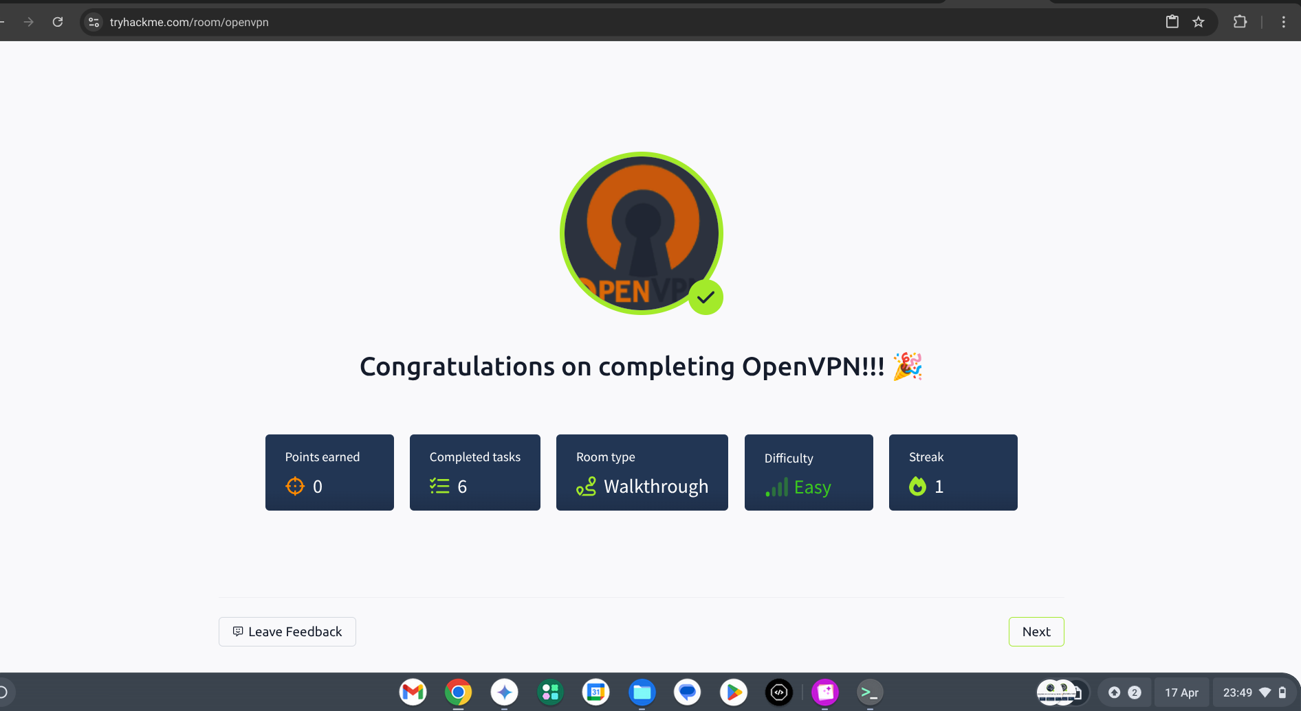

**7. Beginner Path Introduction**

* **✅ Room Name and Link:** Beginner Path Introduction -<https://tryhackme.com/room/beginnerpathintro>
* **🎯 Learning Objective:** To provide a detailed overview of the TryHackMe Beginner Path and its modules, and to help users understand the structured learning approach.
* **🛠 Key Tools/Commands Used:** TryHackMe Learning Paths (navigation), Module Overviews (reviewing content), Room Previews (exploring individual rooms).
* **🧠 Concepts Learned:**
  + **Beginner Path Structure:** Understanding the organization of the Beginner Path into modules and topics.
  + **Module Content and Objectives:** Gaining insights into the specific skills and knowledge covered in each module.
  + **Learning Progression:** Recognizing the gradual progression from basic to more advanced cybersecurity concepts.
  + **Resource Usage:** Understanding how to utilize the various resources provided within the Beginner Path.
* **🔍 Walkthrough / How You Solved It:**
  + Navigated to the "Beginner Path Introduction" room.
  + Explored the Beginner Path and its modules.
  + Reviewed the content and objectives of each module.
  + Identified the key resources and learning materials.
  + Answered the questions related to the Beginner Path.
* **💡 Reflections or Notes:** This room provides a valuable roadmap for users starting their cybersecurity journey on TryHackMe, highlighting the importance of a structured learning approach.

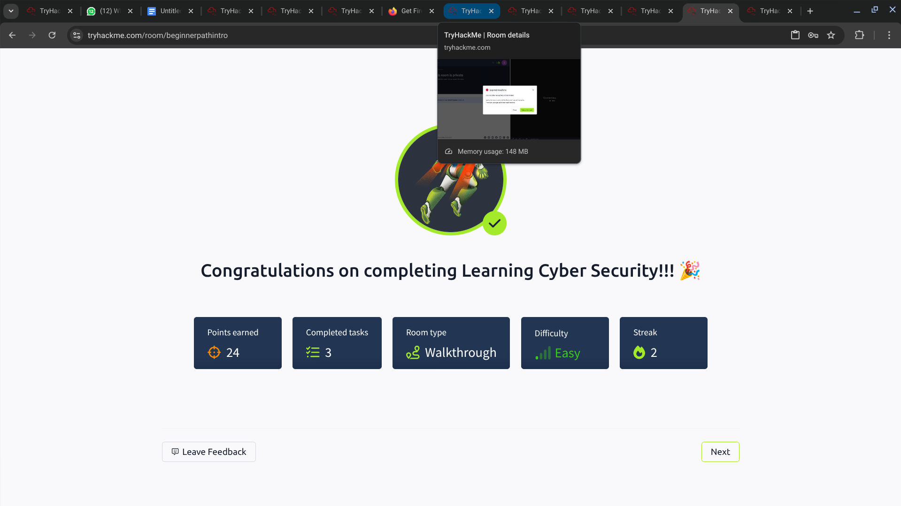

**8. Starting Out in Cyber Security**

* **✅ Room Name and Link:** Starting Out in Cyber Security -<https://tryhackme.com/room/startingoutcybersec>
* **🎯 Learning Objective:** To introduce users to the various roles and career paths available in the cybersecurity field, and to help them understand the skills and knowledge required for success.
* **🛠 Key Tools/Commands Used:** TryHackMe Learning Paths, Cybersecurity Role Descriptions, Skill Assessments.
* **🧠 Concepts Learned:**
  + **Cybersecurity Roles:** Understanding the different roles within cybersecurity, such as penetration tester, security analyst, and security engineer.
  + **Essential Skills:** Recognizing the key skills required for each role, including technical skills, problem-solving abilities, and communication skills.
  + **Learning Paths:** Exploring the recommended learning paths for different cybersecurity careers.
  + **Career Planning:** Developing a basic understanding of how to plan a career in cybersecurity.
* **🔍 Walkthrough / How You Solved It:**
  + Navigated to the "Starting Out in Cyber Security" room.
  + Reviewed the descriptions of different cybersecurity roles and their responsibilities.
  + Identified the essential skills needed for each role.
  + Explored the recommended learning paths for different careers.
  + Answered the questions related to roles, skills, and learning paths.
* **💡 Reflections or Notes:** This room is invaluable for individuals starting their journey in cybersecurity, offering a clear overview of the field and its career opportunities.

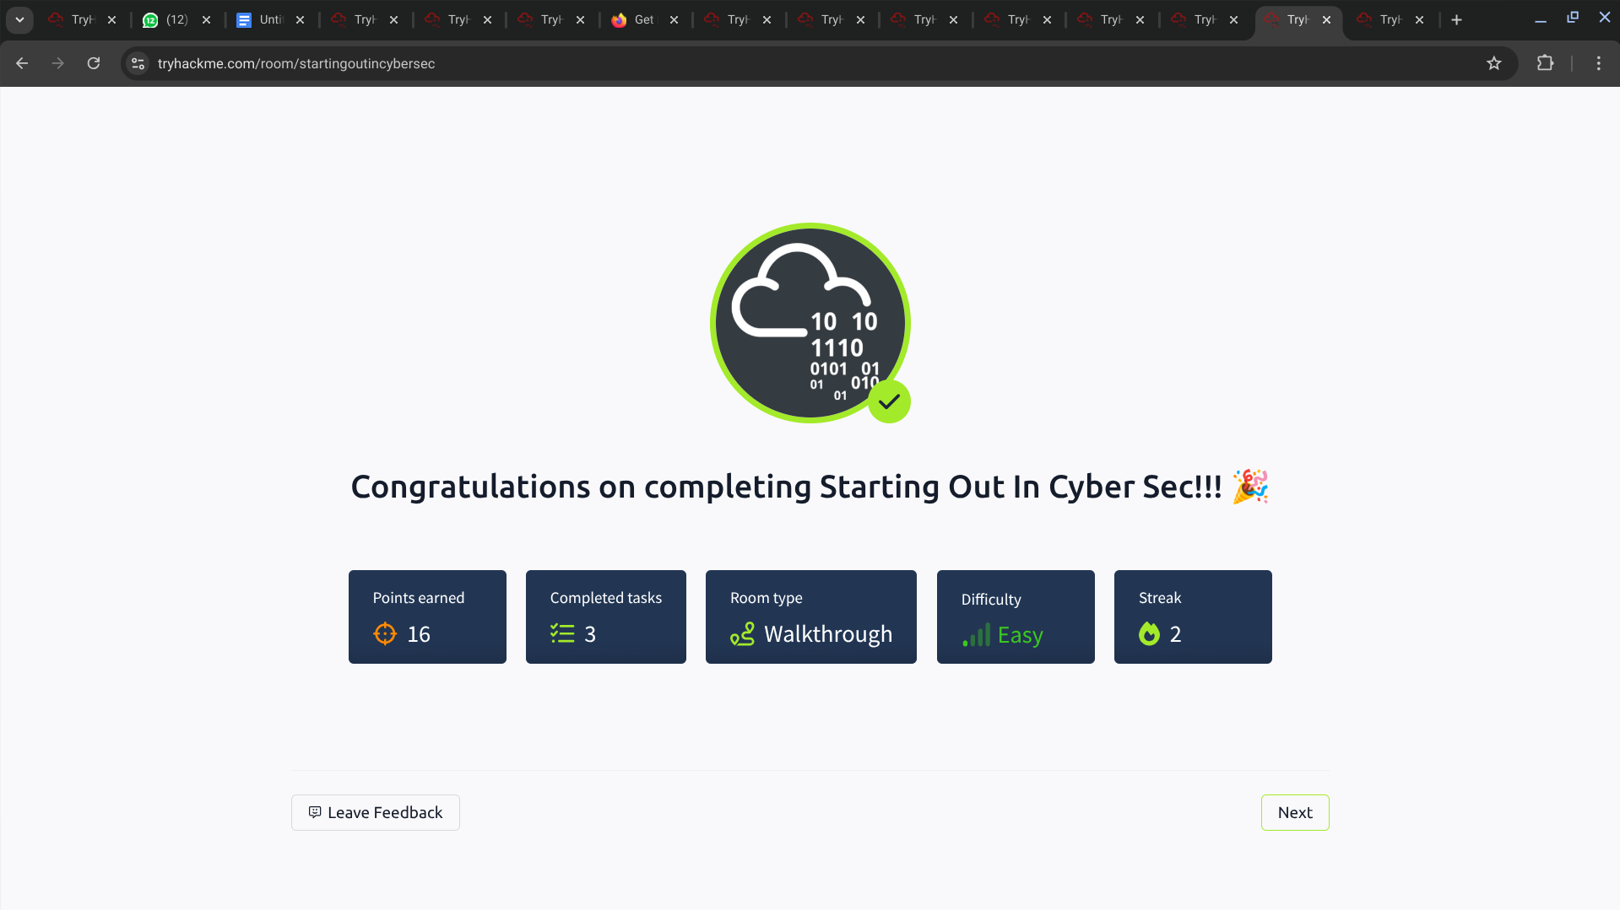

**9. Introduction to Research**

* **✅ Room Name and Link:** Introduction to Research -<https://tryhackme.com/room/introresearch>
* **🎯 Learning Objective:** To equip users with fundamental research skills essential for cybersecurity, including effective searching, understanding credible sources, and utilizing online databases.
* **🛠 Key Tools/Commands Used:** Search Engines (Google, DuckDuckGo), Online Databases (NIST, CVE), Documentation and Whitepapers.
* **🧠 Concepts Learned:**
  + **Effective Searching:** Understanding how to formulate effective search queries using relevant keywords and operators.
  + **Credible Sources:** Identifying and evaluating the credibility of online sources, including documentation, academic papers, and vendor websites.
  + **Utilizing Databases:** Exploring and using online databases such as NIST's National Vulnerability Database (NVD) and the Common Vulnerabilities and Exposures (CVE) database.
  + **Research Methodologies:** Developing basic research methodologies for cybersecurity tasks.
* **🔍 Walkthrough / How You Solved It:**
  + Navigated to the "Introduction to Research" room.
  + Learned how to use search engines effectively by formulating relevant queries.
  + Practiced refining search results to find specific information.
  + Identified and assessed the credibility of different online sources.
  + Explored online databases such as NIST NVD and CVE to search for vulnerabilities.
  + Answered the questions related to research techniques, credible sources, and database utilization.
* **💡 Reflections or Notes:** This room is crucial for developing essential research skills needed for any cybersecurity professional. It highlights the importance of effective searching, evaluating sources, and utilizing databases to gather reliable information.

